小学号： 姓名：

- 作业

1 According to the waveform of the modulating signal shown in following Figure, plot the waveforms of the DSB signal and the AM signal respectively. Compare the differences of their output waveforms after passing through the envelope detector.
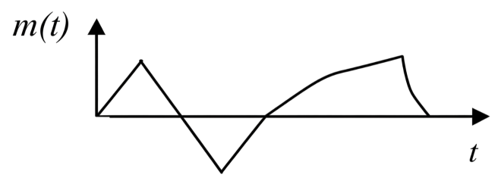
DSB： | DSB包络检波输出波形
AM： | AM包络检波输出波形

2 The amplitude of a single-tone frequency-modulated wave is 10 V, and its instantaneous frequency is $\text{f}\text{(}\text{t}\text{)=1}{\text{0}}^{\text{6}}\text{+1}{\text{0}}^{\text{4}}\text{cos}{\text{(}}\text{2}\text{π}\text{×1}{\text{0}}^{\text{3}}\text{t}\text{) (Hz)}$

Find: (1) The expression of this FM wave.
- The maximum frequency deviation, modulation index and bandwidth of this FM wave.

3 The modulating signal is a single-tone cosine signal of 8 kHz. The single-sided power spectral density of channel noise is $n_{0}=5×10^{−15} W/Hz$, and the channel loss $α$ is 80 dB.

If the required output signal-to-noise ratio is 40 dB, find:
- The bandwidth and transmitted power of the AM signal under 100% modulation.

(2) The bandwidth and transmitted power of the FM signal when the modulation index m_{f} is 5.

4 Proof Question证明题: Prove that the transfer function $\text{H}\text{(}\text{ω}\text{)}$ of the VSB filter satisfies:
$$\text{H}\text{(}\text{ω}\text{+}{\text{ω}}_{\text{c}}\text{)+}\text{H}\text{(}\text{ω}\text{−}{\text{ω}}_{\text{c}}\text{)=}\text{C}\text{, |}\text{ω}\text{|≤}{\text{ω}}_{\text{H}}$$
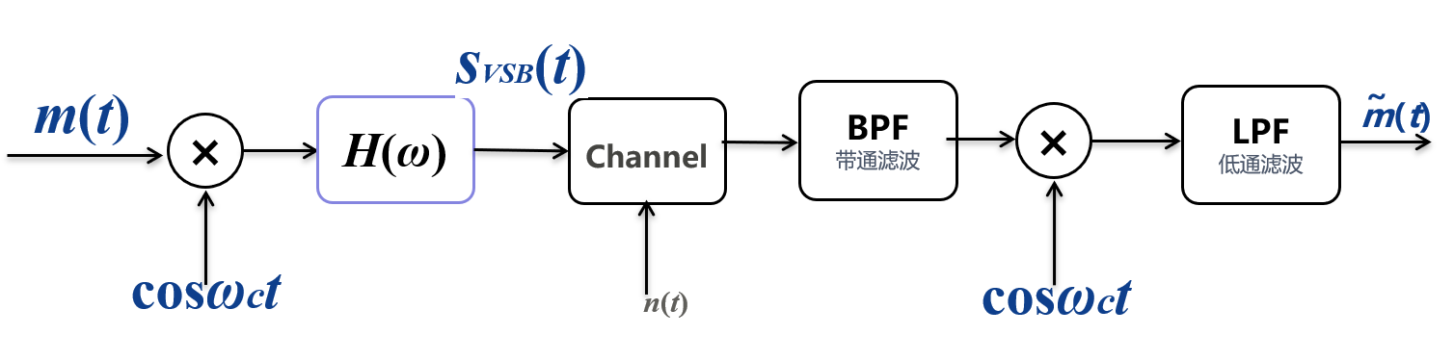
(提示：从 VSB 系统入手，依次分析信号频谱的变化；要求解调恢复的基带频谱相对原始基带无失真，将滤波器传输函数H(ω)视作未知量，推导求解约束条件。)

5 (matlab仿真) The expressions of the modulated signals are given as follows:
- ${\text{s}}_{\text{DSB}}\text{(}\text{t}\text{)=}\text{cos}{\text{(}}\text{2}\text{π}{\text{f}}_{\text{m}}\text{t}\text{)}\text{cos}{\text{(}}\text{2}\text{π}{\text{f}}_{\text{c}}\text{t} \text{)}$;
- ${\text{s}}_{\text{AM}}\text{(}\text{t}\text{)=[1+0.}\text{8cos( }\text{2}\text{π}{\text{f}}_{\text{m}}\text{t} \text{)]}\text{cos}{\text{(}}\text{2}\text{π}{\text{f}}_{\text{c}}\text{t} \text{)}$. ( m_{a=}0.8 )
Where ${\text{f}}_{\text{m}}\text{=4 kHz, }{\text{f}}_{\text{c}}\text{=}\text{10}{\text{f}}_{\text{m}}$. Simulate their waveforms and spectrum respectively. Also discuss the influence of amplitude sensitivity m_{a} on AM signals.

6 (matlab仿真)Given the modulating signal $m(t)=\cos{(}2000πt)+\cos{(}4000πt)$ and the carrier $\cos{(}10^{4}πt)$ for SSB modulation. Simulate SSB signal’s waveform signal and spectrum.包括上边带及双边频谱，下边带及双边频谱，分开仿真，出四个图。

(附加题，选做) Sixty analog voice signals are transmitted by frequency-division multiplexing. The frequency range of each voice signal is 0~4 kHz (including guard bands). First, 12 telephone channels are multiplexed into one group. For the n-th channel, the carrier frequency is ${\text{f}}_{\text{cn}}\text{=112−4}\text{n}\text{, }\text{(}\text{n}\text{=1,2,…,12}$, ) using lower-sideband modulation. Then 5 such groups are multiplexed (still with lower-sideband modulation) into one supergroup, containing 60 telephone channels, occupying the frequency range of 312~552 kHz.

Find: (1) The occupied frequency range and bandwidth of one basic group.
- The carrier frequency of each supergroup.

